**Trend Alert**

Manufacturers of e-cigarettes are using synthetic nicotine to exploit a regulatory loophole and continue selling the sweet and fruity flavored products that ignited the youth vaping epidemic that continues today. Two products to be aware of are Zyn and Lucy.

Zyn is among the new products being marketed to youth. They come in a small white round container, looking similar to a popular breath mint container. Inside are small white punches, containing powdered nicotine, which is often synthetic. Additionally, flavoring and sweeteners are added, as well as other chemicals. The user places the small white pouch between their lip and gums, similar to chewing tobacco, but not as messy or detectable. The user can feel the effects of the pouch for up to 30 minutes and they can be easily discarded.

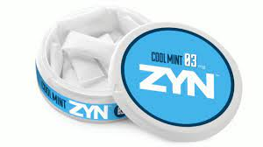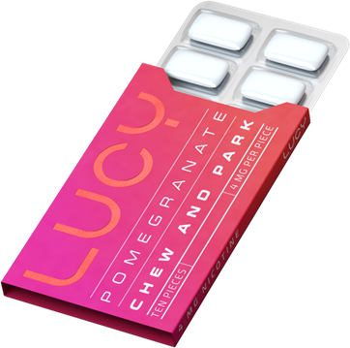

Lucy is a type of nicotine gum. This product has been around for decades, but has recently received a makeover, making the gum more appealing to youth. Lucy was initially released as a cessation tool or nicotine replacement therapy, but unlike Nicorette, Lucy’s colorful pack design, emphasis on flavors and minimal nicotine warnings, attract youth and non-nicotine-users to initiate nicotine use. The gum is chewed for 10-15 seconds to activate the nicotine release, then placed under the tongue or cheek.

Keep in mind that these are only 2 examples of the oral nicotine products, there are many other products including lozenges, strips and sticks, all containing nicotine and flavoring. Many are sold in convenience stores, but are also available via online retailers, including Amazon. Keep your eyes out for these products. Please reach out to Candi Davenport MS LADC with questions at [cdavenport@relatemn.org](mailto:cdavenport@relatemn.org).